|  |  |  |  |  |  |  |  |  |  |  |  |  |  |  |  |  |  |  |
| --- | --- | --- | --- | --- | --- | --- | --- | --- | --- | --- | --- | --- | --- | --- | --- | --- | --- | --- |
| 1 | hydrogen  **1**  1  **H**  1.008 | 2 outer-shell  electrons |  |  |  |  |  |  |  |  |  |  | **Group**  **17**  **Group**  **16**  **Group**  **15**  **Group**  **14**  **Group**  **13**  **Group**  **2**  3 outer-shell  electrons  5 outer-shell  electrons  4 outer-shell  electrons  6 outer-shell  electrons  7 outer-shell  electrons |  |  |  |  | helium  **2**  2  **He**  4.00 |
| 2 | lithium  **3**  2  1  **Li**  6.94 | beryllium  **4**  2  2  **Be**  9.01 |  |  |  |  |  |  |  |  |  |  | boron  **5**  2  3  **B**  10.81 | carbon  **6**  2  4  **C**  12.01 | nitrogen  **7**  **N**  14.01 | oxygen  **8**  2  6  **O**  16.00 | fluorine  **9**  2  7  **F**  19.00 | neon  **10**  2  8  **Ne**  20.18  2  8  8 |
| 3 | sodium  **11**  **Na**  22.99 | magnesium  **12**  **Mg**  24.31 | **Group**  **3**  **Group**  **11**  **Group**  **12**  **Group**  **9**  **Group**  **10**  **Group**  **8**  **Group**  **7**  **Group**  **6**  **Group**  **5**  **Group**  **4** | The transition metals (from Group 3 to Group 12) generally have 1 or 2 outer-shell electrons. |  |  |  |  |  |  |  |  | aluminium  **13**  **Al**  26.98 | silicon  **14**  **Si**  28.09 | phosphorus  **15**  **P**  30.97 | sulfur  **16**  **S**  32.06 | chlorine  **17**  **Cl**  35.45 | argon  2  8  1  2  8  2  2  8  7  2  8  6  2  8  5  2  8  4  2  8  3  2  5  **18**  **Ar**  39.95 |
| 4 | potassium  **19**  2  88  1  **K**  39.10 | calcium  **20**  2  88  2  **Ca**  40.08 | scandium  **21**  **Sc**  44.96 | titanium  **22**  **Ti**  47.87 | vanadium  **23**  **V**  50.94 | chromium  **24**  **Cr**  52.00 | manganese  **25**  **Mn**  54.94 | iron  **26**  **Fe**  55.85 | cobalt  **27**  **Co**  58.93 | nickel  **28**  **Ni**  58.69 | copper  **29**  **Cu**  63.55 | zinc  **30**  **Zn**  65.38 | gallium  **31**  **Ga**  69.72 | germanium  **32**  **Ge**  72.63 | arsenic  **32**  **As**  74.92 | selenium  **34**  **Se**  78.97 | bromine  **35**  **Br**  79.90 | krypton  **36**  **Kr**  83.80 |
| 5 | rubidium  **37**  **Rb**  85.47 | strontium  **38**  **Sr**  87.62 | yttrium  **39**  **Y**  88.91 | zirconium  **40**  **Zr**  91.22 | niobium  **41**  **Nb**  92.91 | molybdenum  **42**  **Mo**  95.95 | technetium  **43**  **Tc**  (98) | ruthenium  **44**  **Ru**  101.07 | rhodium  **45**  **Rh**  102.91 | palladium  **46**  **Pd**  106.42 | silver  **47**  **Ag**  200.59 | cadmium  **48**  **Cd**  112.41 | indium  **49**  **In**  114.82 | tin  **50**  **Sn**  118.71 | antimony  **51**  **Sb**  121.76 | tellurium  **52**  **Te**  127.60 | iodine  **53**  **I**  126.90 | xenon  **54**  **Xe**  131.29 |
| 6 | caesium  **55**  **Cs**  132.91 | barium  **56**  **Ba**  137.33 | lanthanides  **57-71** | hafnium  **72**  **Hf**  178.49 | tantalum  **73**  **Ta**  180.95 | tungsten  **74**  **W**  183.84 | rhenium  **75**  **Re**  186.21 | osmium  **76**  **Os**  190.23 | iridium  **77**  **Ir**  192.22 | platinum  **78**  **Pt**  195.08 | gold  **79**  **Au**  196.97 | mercury  **80**  **Hg**  200.59 | thallium  **81**  **Tl**  204.38 | lead  **82**  **Pb**  207.20 | bismuth  **83**  **Bi**  208.98 | polonium  **84**  **Po**  (209) | astatine  **85**  **At**  (210) | radon  **86**  **Rn**  (222) |
| 7 | francium  **87**  **Fr**  (223) | radium  **88**  **Ra**  (226) | actinides  **89-103** | rutherfordium  **104**  **Rf**  (267) | dubnium  **105**  **Db**  (268) | seaborgium  **106**  **Sg**  (269) | bohrium  **107**  **Bh**  (270) | hassium  **108**  **Hs**  (277) | meitnerium  **109**  **Mt**  (278) | darmstadtium  **110**  **Ds**  (281) | roentgenium  **111**  **Rg**  (282) | copernicium  **112**  **Cn**  (285) | nihonium  **113**  **Nh**  (286) | flerovium  **114**  **Fl**  (289) | moscovium  **115**  **Mc**  (290) | livermorium  **116**  **Lv**  (293) | tennesine  **117**  **Ts**  (294) | oganesson  **118**  **Og**  (294) |
|  |  |  |  |  |  |  |  |  |  |  |  |  |  |  |  |  |  |  |
|  |  |  |  | lanthanum  **57**  **La**  138.91 | cerium  **58**  **Ce**  140.12 | praseodymium  **59**  **Pr**  140.91 | neodymium  **60**  **Nd**  144.24 | prometheum  **61**  **Pm**  (145) | samarium  **62**  **Sm**  150.36 | europium  **63**  **Eu**  151.96 | gadolinium  **64**  **Gd**  157.25 | terbium  **65**  **Tb**  158.93 | dysprosium  **66**  **Dy**  162.50 | holmium  **67**  **Ho**  164.93 | erbium  **68**  **Er**  167.26 | thulium  **69**  **Tm**  168.93 | ytterbium  **70**  **Yb**  173.05 | lutetium  **71**  **Lu**  174.97 |
|  |  |  |  | actinium  **89**  **Ac**  (227) | thorium  **90**  **Th**  232.04 | protactinium  **91**  **Pa**  231.04 | uranium  **92**  **U**  238.03 | neptunium  **93**  **Np**  (237) | plutonium  **94**  **Pu**  (244) | americium  **95**  **Am**  (243) | curium  **96**  **Cm**  (247) | berkelium  **97**  **Bk**  (247) | californium  **98**  **Cf**  (251) | einsteinium  **99**  **Es**  (252) | fermium  **100**  **Fm**  (257) | mendelevium  **101**  **Md**  (258) | nobelium  **102**  **No**  (259) | lawrencium  **103**  **Lr**  (266) |

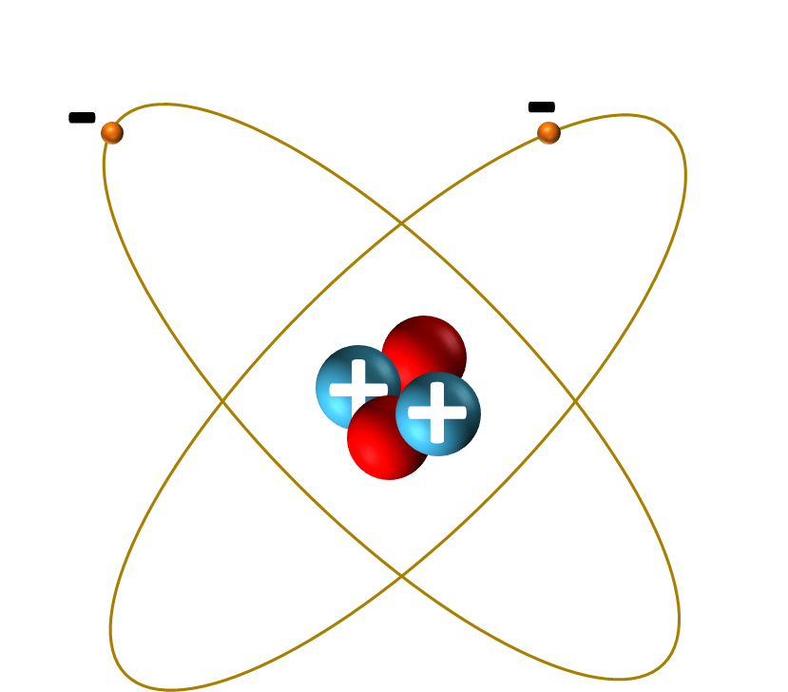

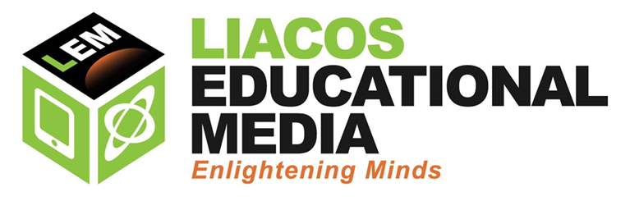

Elements have the same number of electrons as protons.

When **Group 1** elements react, they **lose** an electron and form ions with a single positive charge. Eg. Li+, Na+, K+ etc.

When **Group 2** elements react, they **lose** 2 electrons and form ions with a double positive charge. Eg. Be2+, Mg2+, Ca2+ etc.

When **Group** **17** elements react with metals, they **gain** 1 electron and form ions with a single negative charge. Eg. F-, Cl-, Br- etc.

When **Group 16** elements react with metals, they **gain** 2 electrons and form ions with a double negative charge. Eg. O2-, S2-, Se2- etc.

**Group 18** elements do not react at all.

Outer-shell electrons are also called valence electrons.

Period number tells you the number of electron shells. Eg. the Period 4 elements (K, Ca, etc.) all have 4 electron shells.

# All atoms of a given element have the same number of protons. The number of neutrons can vary. These different forms of the same type of atom are called isotopes and they are expressed using atomic notation: ${}_{Z}^{A}X$

* **A is the Mass Number**, the no. of protons and neutrons (which are collectively called nucleons) in the nucleus.
* **Z is the Atomic Number**, the no. of protons in the nucleus.
* X is the element.

# For example, lithium comes in two isotopes. ${}_{3}^{7}{Li}$ is one of them. It has an atomic number (Z) of 3, which means it has 3 protons, and it has a mass number (A) of 7, which means it has a total of 7 nucleons. Three of those nucleons are protons, so 4 of them must be neutrons. ${}_{3}^{7}{Li}$ can also be written as lithium-7 or Li-7. ${}_{3}^{6}{Li}$ (or lithium-6 or Li-6) has 3 protons and 3 neutrons (6 nucleons in total).

* Atomic Weight: reflects the average mass number of all isotopes of that particular element on earth.

Download a copy of this periodic table at [www.liacoseducationalmedia.com](http://www.liacoseducationalmedia.com). Visit the **Shedding Light on Atoms Episdoe 4: The Periodic Table** page.

Most elements are metals.

B, Si, Ge, As etc. (shaded yellow and bordered by the black and white border) are metalloids.

The rest (C, N, P, O, S, Se etc.) are non-metals.

The elements that have atomic weights shown in brackets have no stable isotopes; the number shown is the mass number of the isotope with the longest half-life.

**Group**

**1**

1 outer-shell

electron

8 outer-shell

electrons (except He)

**Group**

**18**

Protons have a positive charge. Neutrons are neutral. Protons and neutrons occupy the nucleus of an atom and are similar in mass.

Electrons have a negative charge. Their mass is about $\frac{\text{1}}{\text{1836}}$ of the mass of a proton.

**Periodic Table of the Elements**

element name

**atomic number**

**symbol**

atomic weight

electron shell configuration

(of the 1st 20 elements)

KEY

**Period**